Technical Architecture:

Project Design Phase-II Technology Stack (Architecture & Stack)

|  |  |
| --- | --- |
| Date | 15 October 2022 |
| Team ID | PNT2022TMID53555 |
| Project Name | Project - Gas Leakage Monitoring and Alerting  System for Industries. |
| Maximum Marks | 4 Marks |

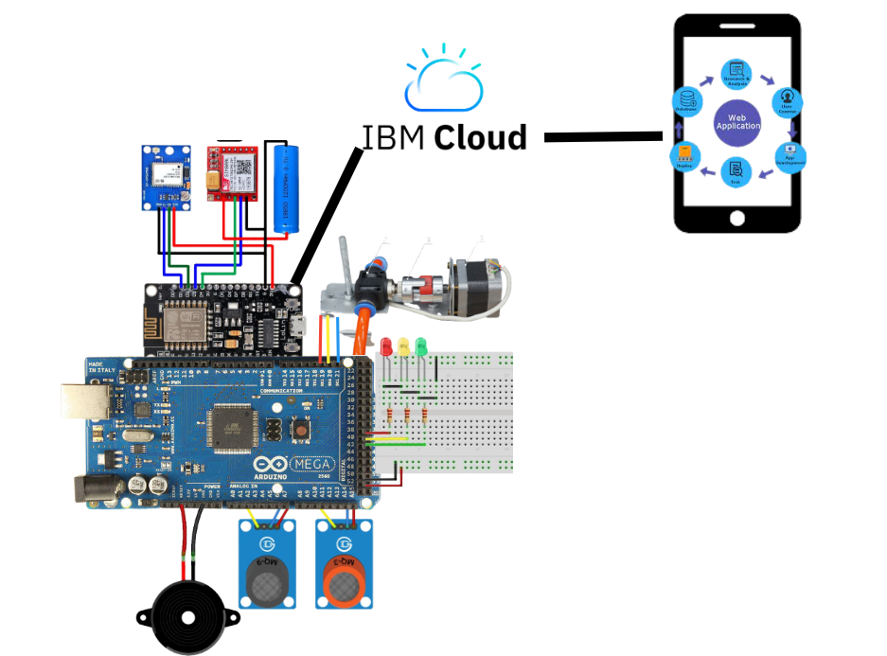

Table-1: Components & Technologies:

|  |  |  |  |
| --- | --- | --- | --- |
| **S.No** | **Component** | **Description** | **Technology** |
| 1. | Arduino MEGA | The Arduino Mega 2560 is **a microcontroller board based on the ATmega2560** (datasheet). It has 54 digital input/output pins (of which 14 can be used as PWM outputs), 16 analog inputs, 4 UARTs (hardware serial ports), a 16 MHz crystal oscillator, a USB connection, a power jack, an ICSP header, and a reset button. | Basically, the processor of the Arduino board uses the Harvard architecture where the program code and program data have separate memory. It consists of two memories such as program memory and data memory. Wherein the data is stored in data memory and the code is stored in the  flash program memory. |
| 2. | LED-Red,Yellow,Green | LED, in full light-emitting diode, in electronics, a semiconductor device that emits infrared or visible light when charged with an electric current. | LEDs operate by electroluminescence, a phenomenon in which the emission of photons is caused by electronic excitation  of a material. |
| 3. | ESP8266 WiFi Module | The ESP8266 WiFi Module is a self-contained SOC with integrated TCP/IP protocol stack that can give any microcontroller access to your WiFi network. The ESP8266 is capable of either hosting an application or  offloading all Wi-Fi networking functions from another application processor. | The ESP8266 is a low-cost Wi-Fi microchip, with built-in TCP/IP networking software, and microcontroller capability |
| 4. | Siren | A siren is **a loud noise-making device**. Civil defense sirens are mounted in fixed locations and used to warn of natural disasters or attacks. Sirens are used on emergency service vehicles such as ambulances, police cars, and fire trucks. There are two general types: mechanical and electronic. | Mechanical sirens **blow air through a slotted disk or rotor**. The cyclic waves of air pressure are the physical form of sound. In many sirens, a centrifugal blower and rotor are integrated into a single piece of material, spun by an electric motor. |
| 5. | MQ5,9,135 gas sensor | The Grove - Gas Sensor (MQ5,9,135) module is useful for gas leakage detection and for monitoring the air quality | A ****gas sensor**** is a device which detects the presence or concentration of gases in the atmosphere. Based on the concentration of the gas the sensor produces a corresponding potential difference by changing the resistance of the material inside the sensor, which can be measured as output voltage. Based on this voltage value the type and concentration of the gas can be estimated. |
| 6. | Valve or Knob with stepper motor | Self-closing Sampling Valves are **safety valves designed to allow safe and quick sampling of volatile gases under pressure on process lines, storage tanks or pressure vessels**. | The Self Closing Valve is opened by means of a lever lifting up the disc from the seat in the valve body. **Spring force will automatically close the valve when the hand lever is unengaged**. The valve is permanently closed using the hand wheel  Automatic control valves are **specialty valves fitted with actuators that can be controlled by temperature or flow sensors**. |
| 7. | GPS module | The NEO-6M GPS module is **a well-performing complete GPS receiver with a built-in 25 x 25 x 4mm ceramic antenna, which provides a strong satellite search capability** | **It can track up to 22 satellites on 50 channels and achieves the industry's highest level of sensitivity i.e. -161 dB tracking, while consuming only 45mA supply current**. |
| 8. | GSM and Fast SMS | GSM (**Global System for Mobile communication**) is a digital mobile network that is widely used by mobile phone users in Europe and other parts of the world.Fast2SMS **provide API for bulk SMS, which ensures security and it is a very reliable source of sending data** | When you send an SMS message, **the message gets transmitted from the sending device to the nearest cell tower**. That cell tower passes the message to an SMS center (SMSC). Then the SMSC forwards the SMS message to a cell tower near the receiving device. Lastly, that tower sends the message to the recipient's device |
| 9. | Mobile Phone | Whenever the excess gas is detected SMS will be sent to a particular phone number. Smoke and gas leakage detectors are very useful in detecting smoke or fire in buildings, and so are the important safety parameters in order to prevent disasters. | The system alerts notifications to the end- user - who responds accordingly with the help of connected devices such as a smartphone on the go. |

|  |  |  |  |
| --- | --- | --- | --- |
| 10. | Web App | An application that is used to the see the gas level, gps location and see the total overview of the system | an app is a type of software that allows you to perform specific tasks. Applications for desktop or laptop computers are sometimes called desktop applications, while those for mobile devices are called mobile apps. **When you open an application, it runs inside the operating system until you close it**. |
| 11. | IBM Cloud | The IBM Cloud platform combines platform as a service (PaaS) with infrastructure as a service (IaaS) to provide an integrated experience. The platform scales and supports both small development teams and organizations, and large enterprise businesses. | Platform as a Service (PaaS) is a cloud computing solution that provides developers with an easy-to-use platform to create their own software, web applications, or other programming projects. |

Table-2: Application Characteristics:

|  |  |  |  |
| --- | --- | --- | --- |
| **S.No** | **Characteristics** | **Description** | **Technology** |
| 1. | Open-Source Frameworks | MQ5,9,135 gas sensor, WiFi, Arduino processor chips. | Internet of Things. |
| 2. | Security Implementations | MQ5,9,135 gas sensor, Alerting device which consists of  siren andLED light. | Internet of Things. |
| 3. | Scalable Architecture | Detecting room temperature, if temperature is above specified temperature, it will alert workers. | Python |
| 4. | Availability | Use of WiFi IP address | Wireless Network |
| 5. | Performance | Performance is efficient | Internet of Things |